Instructions for the preparation

of CC&SW manuscripts with Word

First AUTHORa,[1] and Second AUTHOR b and Third AUTHOR b

a Short Affiliation of First Author

b Short Affiliation of Second and Third Author

ORCiD ID: First AUTHOR <https://orcid.org/....-....-....-....> Second AUTHOR https://orcid.org/....-....-....-...., Third AUTHOR https://orcid.org/....-....-....-....,

**Abstract**. These instructions are designed for the preparation of CC&SW camera-ready manuscripts and should be read carefully.

**Keywords**. CC&SW paper template, STO-CMRE, conference proceedings

# Introduction

This document provides Word instructions for style and layout of CC&SW manuscripts.

The manuscript will be almost identical to the final, published version that will appear in the proceedings, except for the pagination and the insertion of running headlines.

Proofreading as regard to technical content and English usage is the responsibility of the authors.

# Typographical Style and Layout

## Type Area

Please do not modify the layout or formatting of the manuscript (i.e. change of typing areas, margins, etc.).

Check that all the text and illustrations are inside the type area and that the type area is used to the maximum. You may of course end a page with one or more blank lines to avoid ‘widow’ headings, or at the end of a manuscript.

## Page Numbers and Running Headlines

You do not need to include page numbers or running headlines. These elements will be

added by the publisher.

## Font

The font type for running text (body text) is 10 point Times New Roman. There is no need to code normal type (roman text). For literal text, please use typewriter or sans serif. *Italic* or **boldface** should be used for emphasis.

## General Layout

Use single (1.0) line spacing throughout the document.

## (Sub-)Section Headings

Use initial capitals in the headings, except for articles (a, an, the), coordinate conjunctions (and, or, nor), and prepositions, unless they appear at the beginning of the heading. Headings will be automatically numbered.

## Footnotes and Endnotes

Please keep footnotes to a minimum. If they take up more space than roughly 10% of the type area, list them as endnotes, before the bibliography. Footnotes and endnotes should both be numbered in arabic numerals and, in the case of endnotes, preceded by the heading “Endnotes”.

## Lists

### Item List Example

* Item
* Item
* Item

### Numbered List Example

1. Item
2. Item
3. Item

# Citations and Bibliography

Authors’ names should be complete—use full first names (“Donald E. Knuth”) not initials (“D. E. Knuth”) —and the salient identifying features of a reference should be included: title, year, volume, number, pages, article DOI, etc. See the enclosed bibliography, where the examples below are reported.

## Bibliography examples

A paginated journal article [1], an enumerated journal article [2], a reference to an entire

issue [3], a monograph (whole book) [4], a monograph/whole book in a series (see 2a in

spec. document) [5], a divisible-book such as an anthology or compilation [6], however we only output the series if the volume number is given (so series should not be present since it has no vol. no.), a chapter in a divisible book [7], a chapter in a divisible book in a series [8], a multi-volume work as book [9], an article in a proceedings (of a conference, symposium, workshop for example) (paginated proceedings article) [10], a proceedings article with all possible elements [11], an example of an enumerated proceedings article [12], an informally published work [13], a doctoral dissertation [14], a master’s thesis: [15], an online document / world wide web resource [16, 17, 18], a video game (Case 1) [19] and (Case 2) [20] and [21] and (Case 3) a patent [22], work accepted for publication [23], prolific author [24] and [25]. Other cites might contain ‘duplicate’ DOI and URLs (some SIAM articles) [26]. Multi-volume works as books [27]. A couple of citations with DOIs: [28, 26]. Online citations: [29, 16, 30, 31].

# Figures and Tables

Do not collect illustrations at the back of your article, but incorporate them in the text. Position tables and figures with at least 2 lines extra space between them and the running text.

The text should include references to all illustrations and tables. Refer to them in the text as Table 1, Table 2, Figure 1, Figure 2, etc., not with the section or chapter number included, e.g. Table 3.2, Figure 4.3, etc. Do not use the words “below” or “above” referring to the tables, figures, etc.

Your figures should contain a caption which describes the figure to the reader. Figure captions go below the figure. Your figures should also include a description suitable for screen readers, to assist the visually-challenged to better understand your work.

If your figure contains third-party material, you must clearly identify it as such, as shown in the example below.

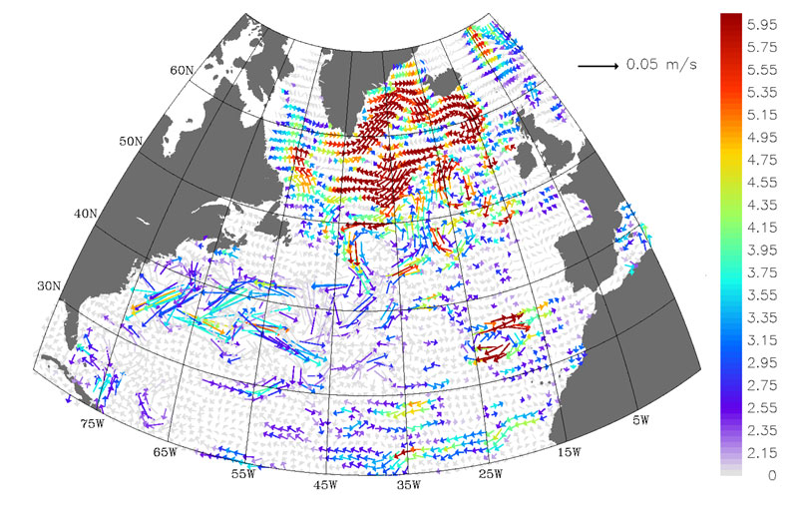

**Figure 1.** Trend Velocities in North Atlantic The trend of the velocities (meters per second per decade) derived from NASA Pathfinder altimeter data for the period May 1992 to June 2002. The colored vectors are statistically significant. Note how the vectors trace the following graphic of the subpolar circulation in reverse direction, which denotes a slowing gyre. Credit: Sirpa Hakkinen, NASA [Public domain], via Wikimedia Commons. (https://commons.wikimedia.org/w/index.php?curid=8009302).

Place figure captions *below* the figure, table captions *above* the table. Use bold for table/figure labels and numbers, e.g.: **Table 1**., **Figure 2**., and roman for the text of the caption. Keep table and figure captions justified. Center short figure captions only.

**Table 1.** Table example.

|  |  |  |
| --- | --- | --- |
| **Left-text** | **Number** | **Right-text** |
| Text | 100 | Text |
| Text | 200 | Text |
| Text | 300 | Text |

Figures and tables should be centered on the page, except for small figures that can fit side by side inside the type area. One or more images can be placed within a figure. Tables and figures should not have text wrapped alongside.

The minimum font size for characters in tables is 8 points, and for lettering in other illustrations, 6 points. Embed the fonts used if the application provides that option. Ensure consistency by using similar sizes and fonts for a group of small figures. To add lettering to figures, it is best to use Helvetica or Arial (sans serif fonts) to avoid effects such as shading, outline letters, etc.

Ensure the resolution of illustrations is sufficient for the printed version of the manuscript.

If you are incorporating screen captures, keep in mind that the text may not be legible after reproduction.

# Equations

Number equations consecutively, not section-wise. Place the numbers in parentheses at the right-hand margin, level with the last line of the equation. Refer to equations in the text as Eq. (1), Eqs. (3) and (5).

 (1)

# Submitting the Manuscript

Submit the following to the volume editors:

1. The main source file (docx), and any other required files. Do not submit more than one version of any item.
2. A high-resolution PDF file generated from the source files you submit.

# Acknowledgements

Identification of funding sources and other support, and thanks to individuals and groups that assisted in the research and the preparation of the work should be included in an acknowledgment section just before the bibliography section in your document.

References

1. P. S. Abril, R. Plant, The patent holder’s dilemma: Buy, sell, or troll?, Communications of the ACM 50 (1) (2007) 36–44.
2. S. Cohen, W. Nutt, Y. Sagic, Deciding equivalances among conjunctive aggregate queries, J. ACM 54 (2).
3. J. Cohen (Ed.), Special issue: Digital Libraries, vol. 39, 1996.
4. D. Kosiur, Understanding Policy-Based Networking, Wiley, New York, NY, 2nd. edn., 2001.
5. D. Harel, First-Order Dynamic Logic, vol. 68 of Lecture Notes in Computer Science, Springer-Verlag, New York, NY, 1979.
6. I. Editor (Ed.), The title of book one, vol. 9 of The name of the series one, University of Chicago Press, Chicago, 1st. edn., 2007.
7. A. Z. Spector, Achieving application requirements, in: S. Mullender (Ed.), Distributed Systems, ACM Press, New York, NY, 2nd. edn., 19–33, 1990.
8. B. P. Douglass, D. Harel, M. B. Trakhtenbrot, Statecarts in use: structured analysis and object-orientation, in: G. Rozenberg, F. W. Vaandrager (Eds.), Lectures on Embedded Systems, vol. 1494 of Lecture Notes in Computer Science, Springer-Verlag, London, 368–394, 1998.
9. D. E. Knuth, The Art of Computer Programming, Vol. 1: Fundamental Algorithms (3rd. ed.), Addison Wesley Longman Publishing Co., Inc., 1997.
10. S. Andler, Predicate Path expressions, in: Proceedings of the 6th. ACM SIGACT-SIGPLAN symposium

on Principles of Programming Languages, POPL ’79, ACM Press, New York, NY, 226–236, , 1979.

1. S.W. Smith, An experiment in bibliographic mark-up: Parsing metadata for XML export, in: R. N. Smythe,

A. Noble (Eds.), Proceedings of the 3rd. annual workshop on Librarians and Computers, vol. 3 of LAC ’10,

Paparazzi Press, Milan Italy, 422–431, 2010.

1. M. V. Gundy, D. Balzarotti, G. Vigna, Catch me, if you can: Evading network signatures with web-based

polymorphic worms, in: Proceedings of the first USENIX workshop on Offensive Technologies, WOOT

’07, USENIX Association, Berkley, CA, 2007.

1. D. Harel, LOGICS of Programs: AXIOMATICS and DESCRIPTIVE POWER, MIT Research Lab

Technical Report TR-200, Massachusetts Institute of Technology, Cambridge, MA, 1978.

1. K. L. Clarkson, Algorithms for Closest-Point Problems (Computational Geometry), Ph.D. thesis, Stanford

University, Palo Alto, CA, uMI Order Number: AAT 8506171, 1985.

1. D. A. Anisi, Optimal Motion Control of a Ground Vehicle, Master’s thesis, Royal Institute of Technology

(KTH), Stockholm, Sweden, 2003.

1. H. Thornburg, Introduction to Bayesian Statistics, URL http://ccrma.stanford.edu/~jos/bayes/bayes.html, 2001.
2. R. Ablamowicz, B. Fauser, CLIFFORD: a Maple 11 Package for Clifford Algebra Computations, version

11, URL http://math.tntech.edu/rafal/cliff11/index.html, 2007.

1. Poker-Edge.Com, Stats and Analysis, URL http://www.poker-edge.com/stats.php, 2006.
2. B. Obama, A more perfect union, Video, URL http://video.google.com/videoplay?docid= 6528042696351994555, 2008.
3. D. Novak, Solder man, in: ACM SIGGRAPH 2003 Video Review on Animation theater Program: Part I - Vol. 145 (July 27–27, 2003), ACM Press, New York, NY, 4, URL <http://video.google.com/> videoplay?docid=6528042696351994555, 2003.
4. N. Lee, Interview with Bill Kinder: January 13, 2005, Comput. Entertain. 3(1)4.
5. J. Scientist, The fountain of youth, patent No. 12345, Filed July 1st., 2008, Issued Aug. 9th., 2009, 2009.
6. B. Rous, The Enabling of Digital Libraries, Digital Libraries 12 (3), to appear.
7. M. Saeedi, M. S. Zamani, M. Sedighi, A library-based synthesis methodology for reversible logic, Microelectron. J. 41 (4) (2010) 185–194.
8. M. Saeedi, M. S. Zamani, M. Sedighi, Z. Sasanian, Synthesis of Reversible Circuit Using Cycle-Based Approach, J. Emerg. Technol. Comput. Syst. 6 (4).
9. M. Kirschmer, J. Voight, Algorithmic Enumeration of Ideal Classes for Quaternion Orders, SIAM J. Comput. 39 (5) (2010) 1714–1747, ISSN 0097-5397, URL http://dx.doi.org/10.1137/080734467.
10. L. Hörmander, The analysis of linear partial differential operators. IV, vol. 275 of *Grundlehren der Mathematischen Wissenschaften [Fundamental Principles of Mathematical Sciences]*, Springer-Verlag,

Berlin, Germany, ISBN 3-540-13829-3, fourier integral operators, 1985.

1. I. T. E. Committee, in: Proceedings of the IEEE International Conference on Web Services, ICWS ’04,

IEEE Computer Society, Washington, DC, USA, ISBN 0-7695-2167-3, 21–22, 2004.

TUG, Institutional members of the TEX Users Group, URL <http://www.tug.org/instmem.html>, 2017.

1. R Core Team, R: A Language and Environment for Statistical Computing, URL https://www.R-project.org/, 2019.
2. S. Anzaroot, A. McCallum, UMass Citation Field Extraction Dataset, URL http://www.iesl.cs.umass.edu/data/data-umasscitationfield, 2013.
3. Appendix

If you have appendixes, they must be included after the reference section.

1. Corresponding Author: Author Name, Contact details.